|  |  |  |  |  |  |
| --- | --- | --- | --- | --- | --- |
|  | Consumer Confidence Report 2022  **This is the annual report of your drinking water to help you be better informed and is also required to be distributed annually by Federal Safe Drinking Water Act (SDWA) and the State of Washington.** | | |  | |
| **NEWS**  **Water Use Efficiency**  All water districts are required to set measurable water efficiency goals. This means the difference between metered water from source and metered water billed. Belfair Water District had a loss for 2022 of 11% which is down from 11.2%. The State of Washington set goals for all districts to be below 10%. As of the end of 2022 we have changed out 2/3 or the districts consumer meters and all of our source meters. We have been prompt on leak repairs, plus we scheduled with a leak detection company and evaluated 25% of the District. Seven leaks were found and repaired promptly.  **Your Drinking Water Supply**  Belfair Water District has four ground water wells, three wells on the south end of the district, one well on the north end. These wells provide water from deep aquifers (ground water) minimally treated with chlorine, then pumped to five reservoirs around the district and tested as required by  Washington Department of Health 1-800-525-0127 | | | | |
| **We performed maintenance, cleaned & painted all hydrants on south end of the District with a goal to have the rest of the Districts hydrants completed in 2023. We also installed new storz adapters on all fire hydrants for ease of operation during an emergency.**  **The installation of all new water mains & fire hydrants was completed on 144 lot development by the post office with the completion of the 250-unit apartment complex to be finished in 2023.** | | **The District is pleased to announce that we have added a full time employee, Alex, to our field staff. Alex has worked with the District for 5 years part time throughout summers.**  **We installed a new air/vac assembly on top of Alderwood RD**  **Our meter reading system has upgraded software.**  **No violations reported for 2022.**  **We continue to be committed to the highest quality of drinking water and to be in good standing with the community and state of Washington.** | Meet our staff  Greg Born, Chairman  Jill Satran-Loudin, Treasurer Mike Pope, Secretary  **General Manager:**  Dale Webb, 22 years’ experience in the waterworks industry  **Operations Manager:**  James Freeman, 23 years hands-on in the waterworks industry  **Field Service Technician:**  Alex Gobble  **Office Manager:**  Lisa Douglas  **Public Participation**  Water District customers are invited to attend regular Commissioner District meetings.  When: 2nd and 4th Tuesdays of the month  **Time: 3:00pm**  Where: 22451 Highway 3 Belfair, WA 98528  For more information contact Dale Webb (360)275-3008  www.belfairwater.org | |
| Coliform Sampling  Belfair Water District #1 is required to take three total coliform bacteria samples a month. Although TC bacteria by itself are in fact common in the environment, the presence of TC bacteria indicates that more testing is required. | | |

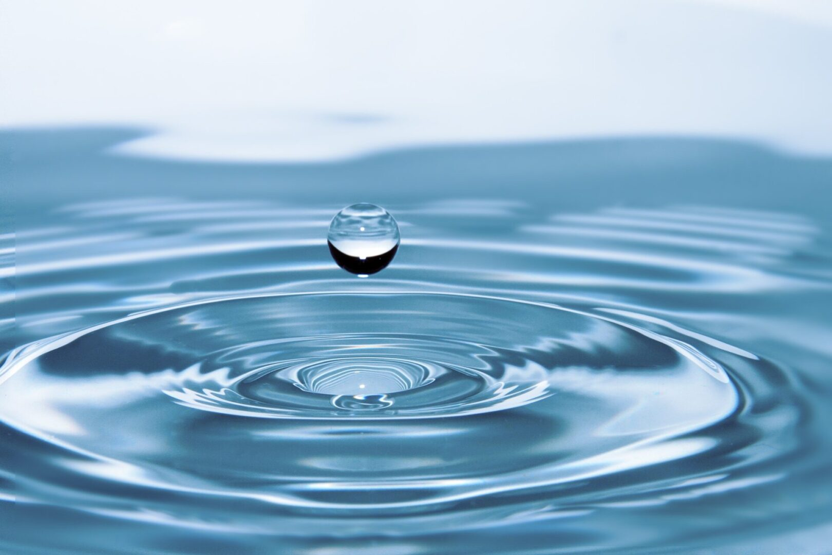

**2022 Water Quality Data Table**

The Environmental Protection Agency regulates the frequency of sampling for various contaminates.

|  |  |  |  |  |  |  |
| --- | --- | --- | --- | --- | --- | --- |
| **Contaminant/Units** | **MCLG** | **MCL** | **Result** | **Test Date** | **Violation** | **Typical Source** |
| **Trihalomethanes** | **N/A** | **80ppb** | **ND** | **8-1-2022** | **NO** | **By product of drinking water by disinfection** |
| **Halo- Acetic Acids** | **60ppb** | **60ppb** | **ND** | **08-01-2022** | **NO** | **By product of drinking water by disinfection** |
| **Inorganic Chemicals** |  |  |  |  |  |  |
| **Nitrate** | **10ppm** | **10ppm** | **<0.20** | **09-14-2022** | **NO** | **Runoff from fertilizer use; Leaching from septic tanks, sewage erosion of natural deposits** |
| **Volatile Organic Compounds** |  |  |  |  |  |  |
| **Iron** | **0.3ppm** | **0.3ppm** | **<0.10ppm** | **10-17-2022** | **NO** | **Naturally Occurring** |
| **Lead** | **0** | **.15ppb** | **1ppb** | **07-28-2020** | **NO** | **Plumbing Materials** |
| **Arsenic** | **10ppb** | **10ppb** | **ND** | **10-24-2019** | **NO** | **Erosion of natural deposits** |
| **Copper** | **1.3ppm** | **1.3ppm** | **ND** | **07-28-2020** | **NO** | **Plumbing Fixture** |

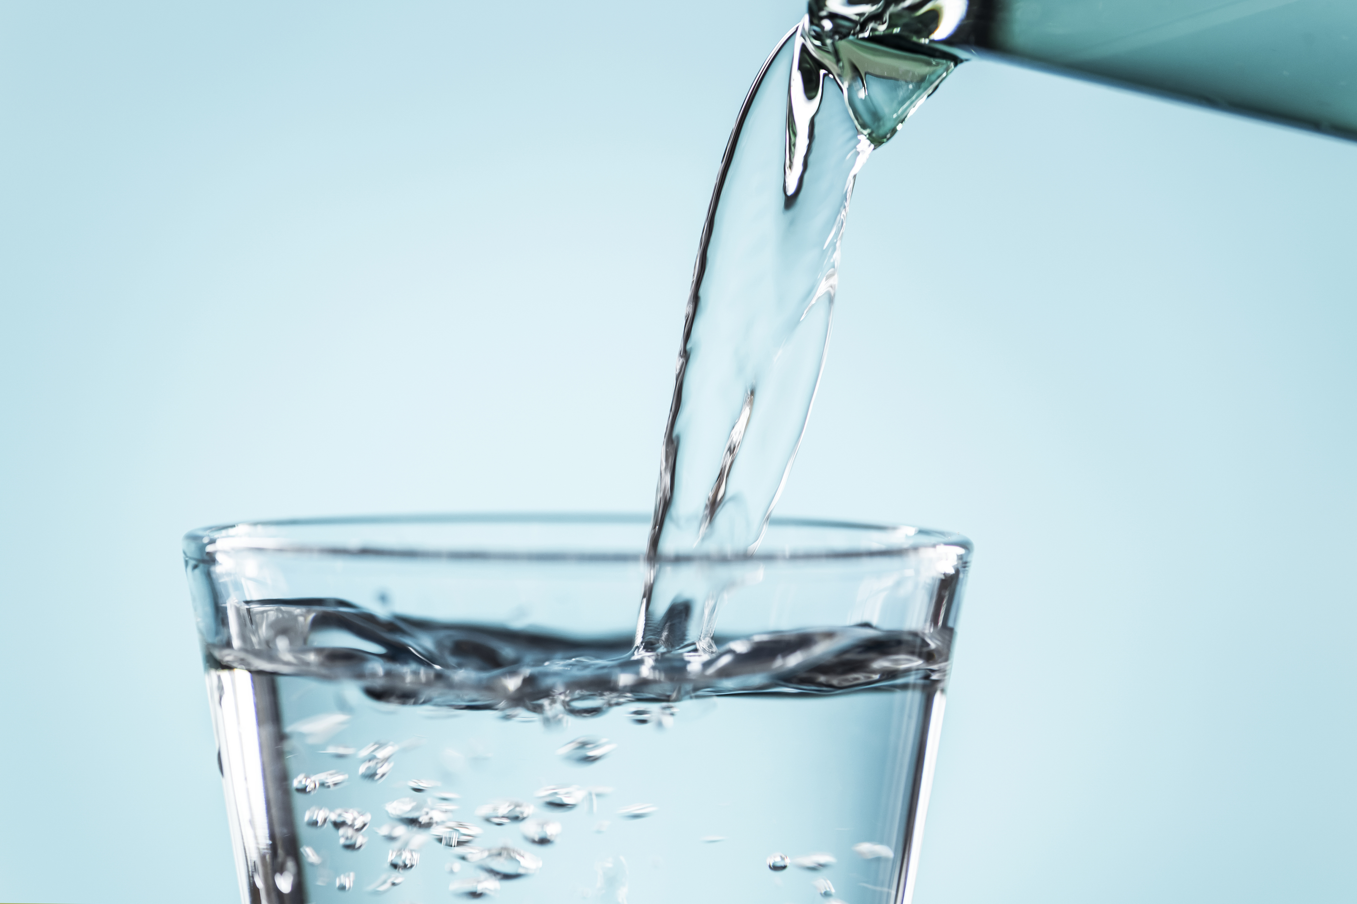



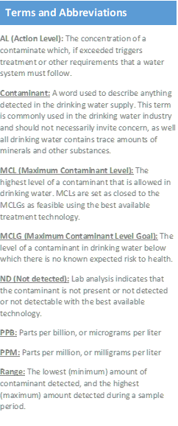

Drinking water, including bottled water, may reasonably be expected to contain at least small amounts of some contaminants. The presence of contaminants does not necessarily indicate that water poses a health risk. More information about contaminants and potential health effects can be obtained by calling the EPA’s Safe Drinking Water Hotline (1-800-426-4791)

Some people may be more vulnerable to contaminants in drinking water than the general population. Immunocompromised persons such as persons with cancer undergoing chemotherapy, persons who have undergone organ transplants, people with HIV/AIDS or other immune system disorders, some elderly, and infants can be particularly at risk from infections. These people should seek advice about drinking water from their health care providers. EPA/CDC guidelines on appropriate means to lessen the risk of infection by Cryptosporidium and other microbial contaminants are available from the Safe Drinking Water Hotline (1-800-426-4791)

important health information



**10 Ways to Conserve Water**

1. Update appliances to high efficiency
2. Run dishwasher & clothes washer at full capacity
3. Take shorter showers
4. Check for leaking faucets
5. Water plants & lawns at night
6. Wash vehicles at the car wash
7. Install low flow shower heads & toilets
8. Use a broom to clean sidewalks & driveways
9. Turn water off while brushing teeth & shaving
10. Put a mulch around shrubs to hold water in